TRYOUTS
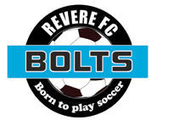

Our BOLTS teams are always welcoming players who are looking to play in the Premier Leagues with a family-based soccer Club program that is committed to long term individual player development., we invite you to join us on field for a team training . There is no cost for an on-field tryout, but you must register online (see links below). Our coaches will contact you directly to set up a time for you to come see what REVERE FC BOLTS is all about.
CLICK HERE FOR REGISTRATION
Contact our Coaches Director
Brian Salazar at : 781-526-3643

